Chapter-1:

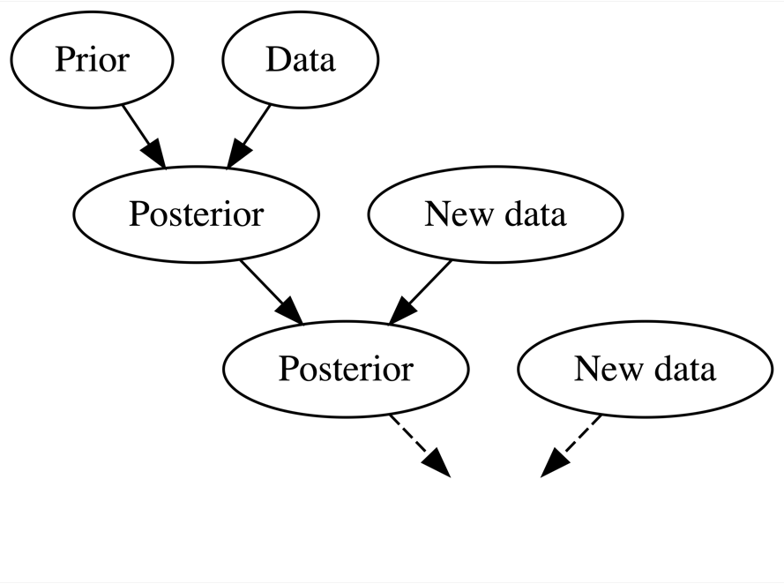

Figure 1.2

**Interpreting probability**

* In the Bayesian philosophy, a probability measures the **relative plausibility** of an event.
* The frequentist philosophy is so named for its interpretation of probability as the **long-run relative frequency** of a repeatable event.

Thus in the coin flip example, a Bayesian would conclude that Heads and Tails are equally likely. In contrast, a frequentist would conclude that if we flip the coin over and over and over, roughly 1/2 of these flips will be Heads.

Let’s try applying these same ideas to the question 2 setting in which a pollster declares that candidate A has a 0.9 probability of winning the upcoming election. This routine election calculation illustrates cracks within the frequentist interpretation. Since the election is a one time event, the long-run relative frequency concept of observing the election over and over simply doesn’t apply. A very strict frequentist interpretation might even conclude the pollster is just wrong. Since the candidate will either win or lose, their win probability must be either 1 or 0. A less extreme frequentist interpretation, though a bit awkward, is more reasonable: in long-run *hypothetical* repetitions of the election, i.e. elections with similar circumstances, candidate A would win roughly 90% of the time.

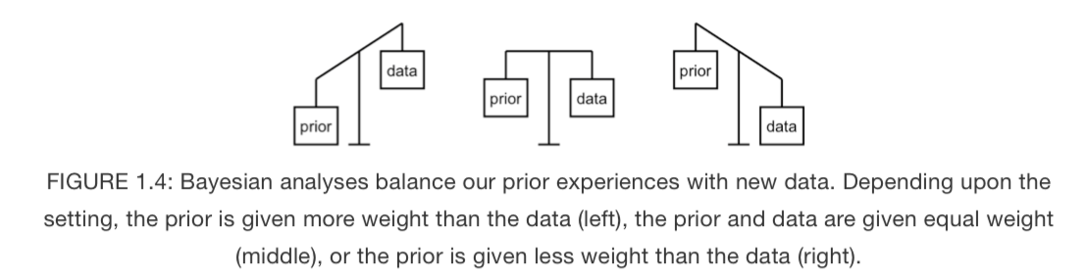

Allowing the posterior to balance out the prior and data is critical to the Bayesian knowledge building process. When we have little data, our posterior can draw upon the power in our prior knowledge. As we collect more data, the prior loses its influence.

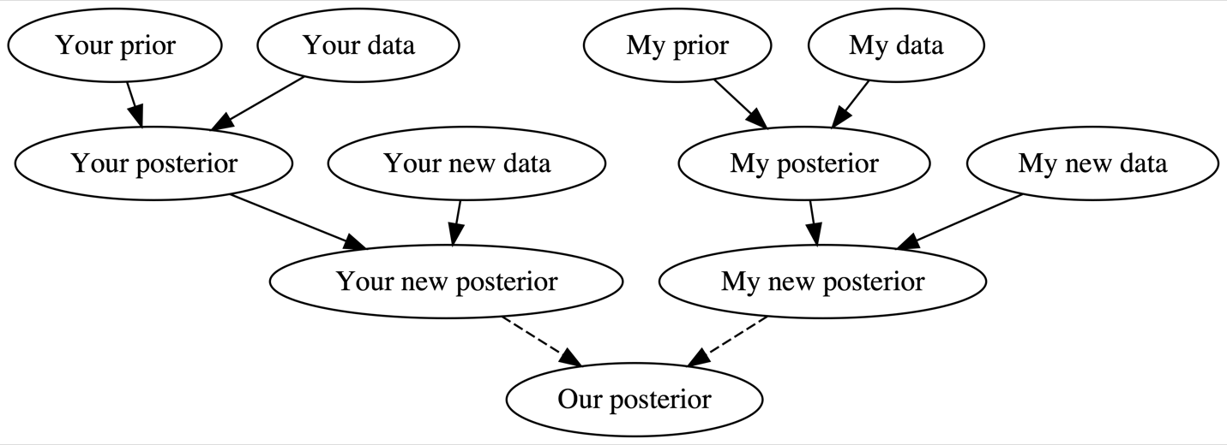

Figure 1.5

Specifically, a **Bayesian** analysis assesses the uncertainty of the hypothesis in light of the observed data, and a **frequentist** analysis assesses the uncertainty of the observed data in light of an assumed hypothesis.

**Asking questions**

In a hypothesis test…

* a Bayesian analysis seeks to answer: in light of the observed data, what’s the chance that the hypothesis is correct?
* a frequentist analysis seeks to answer: if in fact the hypothesis is incorrect, what’s the chance I’d have observed this, or even more extreme, data?

| **test positive** | **test negative** | **total** |
| --- | --- | --- |
| disease | 3 | 1 | 4 |
| no disease | 9 | 87 | 96 |
| total | 12 | 88 | 100 |

In this scenario, a *Bayesian* analysis would ask: given my positive test result, what’s the chance that I actually have the disease? Since only 3 of the 12 people that tested positive have the disease (Table [1.1](https://www.bayesrulesbook.com/chapter-1.html#tab:disease-population)), there’s only a 25% chance that you have the disease. Thus when we take into account the disease’s rarity and the relatively high false positive rate, it’s relatively unlikely that you actually have the disease. What a relief.

Recalling Section [1.1.2](https://www.bayesrulesbook.com/chapter-1.html#bayes-v-freq-probability), you might anticipate that a frequentist approach to this analysis would differ. From the frequentist standpoint, since disease status isn’t repeatable, the probability you have the disease is either 1 or 0 – you have it or you don’t. To the contrary, medical testing (and data collection in general) *is* repeatable. You can get tested for the disease over and over and over. Thus a *frequentist*analysis would ask: if I don’t actually have the disease, what’s the chance that I would’ve tested positive? Since only 9 of the 96 people without the disease tested positive, there’s a roughly 10% (9/96) chance that you would’ve tested positive even if you didn’t have the disease.

Modeling a **quantitative** response variable Y is a **regression task**.

• Modeling a **categorical** response variable Y is a **classification task**.

**1.4 Chapter summary**

In Chapter 1, you learned how to think like a Bayesian. In the fundamental Bayesian knowledge building process (Figure [1.2](https://www.bayesrulesbook.com/chapter-1.html#fig:bayes-diagram)):

* We construct our **posterior knowledge** by balancing **information from our data** with our **prior knowledge**;
* As more data comes in, we continue to **refine** this knowledge as the influence of our original prior fades into the background; thus
* In light of more and more data, two analysts that start out with opposing knowledge will converge on the same posterior knowledge.

Chapter-2:

As a valid **probability model** must: (1) it accounts for all possible events (all articles must be fake or real); (2) it assigns prior probabilities to each event; and (3) these probabilities **sum to one**.

**Conditional vs unconditional probability**

Let A and B be two events. The **unconditional probability** of A, P(A), measures the probability of observing A, without any knowledge of B. In contrast, the **conditional probability** of A given B, P(A|B), measures the probability of observing A in light of the information that B occurred.

**Independent events**

Two events A and B are **independent** if and only if the occurrence of Bdoesn’t tell us anything about the occurrence of A:

P(A|B)=P(A)

For example, on its face, the conditional probability P(A|B) measures the uncertainty in event A given we know event B occurs. However, we find ourselves in the opposite situation. We *know* that the incoming article used exclamation points, A. What we *don’t*know is whether or not the article is fake, B or Bc. Thus in this case, we compared P(A|B) and P(A|Bc) to ascertain the relative **likelihoods** of observing data A under different scenarios of the *uncertain* article status. To help distinguish this application of conditional probability calculations from that when A is uncertain and B is known, we’ll utilize the following **likelihood function** notation L(⋅|A):

L(B|A)=P(A|B) and L(Bc|A)=P(A|Bc).

We present a general definition below, but be patient with yourself here. The distinction is subtle, especially since people use the terms “likelihood” and “probability” interchangeably in casual conversation.

**Probability vs likelihood**

When B is known, the **conditional probability function** P(⋅|B) allows us to compare the probabilities of an unknown event, A or Ac, occurring with B:

P(A|B) vs P(Ac|B).

When A is known, the **likelihood function** L(⋅|A)=P(A|⋅) allows us to evaluate the relative compatibility of events B or Bc with data A:

L(B|A) vs L(Bc|A).

Again, the **likelihood function is not a probability function**, but rather provides a framework to compare the relative compatibility of B and Bc with our exclamation point data.

**Calculating joint and conditional probabilities**

For events A and B, the joint probability of A∩B is calculated by weighting the conditional probability of A given B by the marginal probability of B:

P(A∩B)=P(A|B)P(B)(2.1)

Thus when A and B are independent,

P(A∩B)=P(A)P(B)

Dividing both sides of [(2.1)](https://www.bayesrulesbook.com/chapter-2.html#eq:jointprob) by P(B), and assuming P(B)≠0, reveals the definition of the conditional probability of A given B:

P(A|B)=P(A∩B)P(B)(2.2)

Thus to evaluate the chance that A occurs in light of information B, we can consider the chance that they occur together, P(A∩B), relative to the chance that B occurs at all, P(B).

**Chapter 2**

**Conditional vs unconditional probability**

Let AA and BB be two events. The **unconditional probability** of AA, P(A)P(A), measures the probability of observing AA, without any knowledge of BB. In contrast, the **conditional probability** of AA given BB, P(A|B)P(A|B), measures the probability of observing AA in light of the information that B occurred.

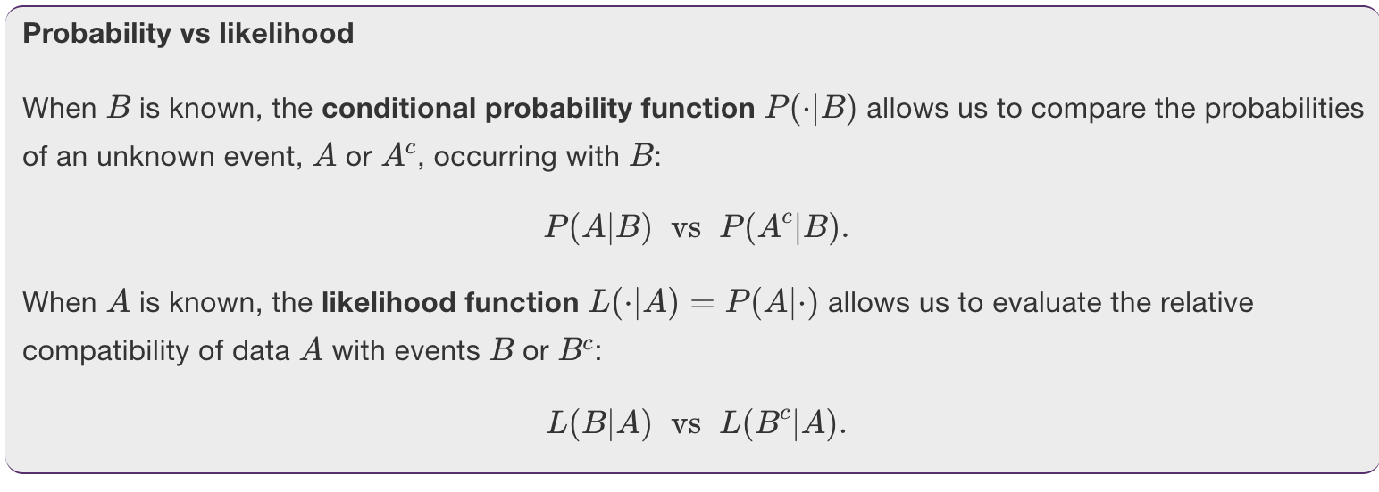

### 2.1.3 Normalizing constants

Though the likelihood function in Table [2.2](https://www.bayesrulesbook.com/chapter-2.html#tab:fakelike) nicely summarizes exclamation point usage in real vs fake news, the **marginal probability** of observing exclamation points across all news articles, P(A)P(A), provides an important point of comparison.

We’re now in a position to answer the ultimate question: What’s the probability that the latest article is fake? Formally speaking, we aim to calculate the **posterior probability** that the article is fake given that it uses exclamation points, P(B|A)P(B|A).

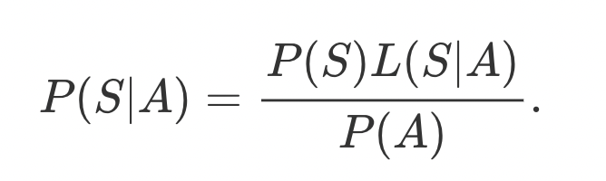

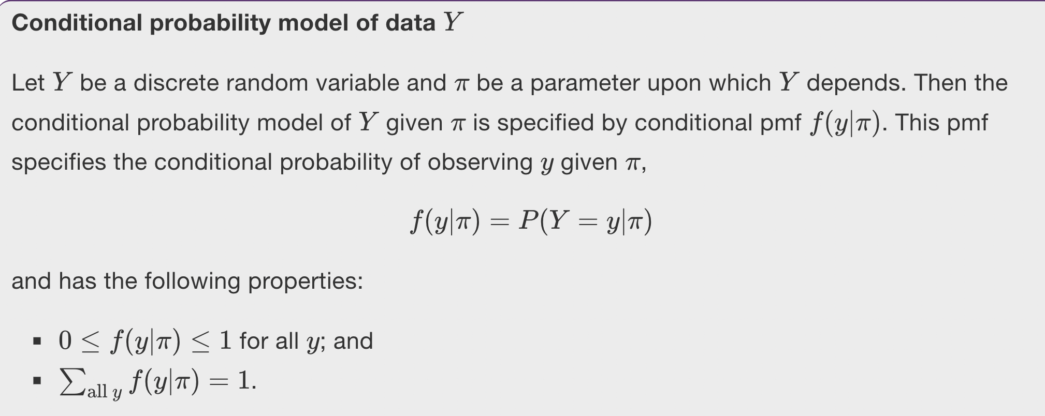

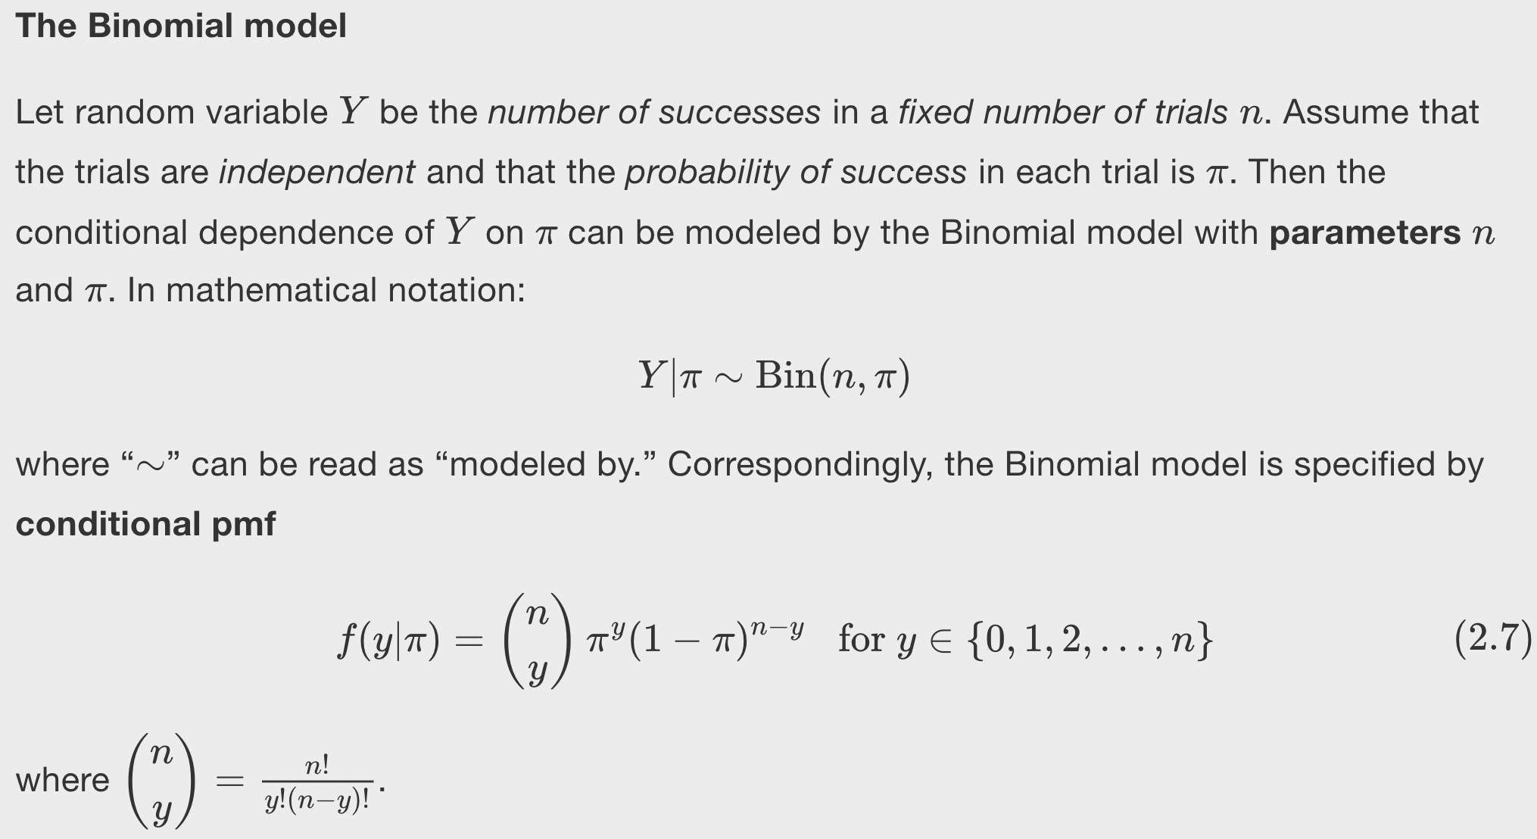

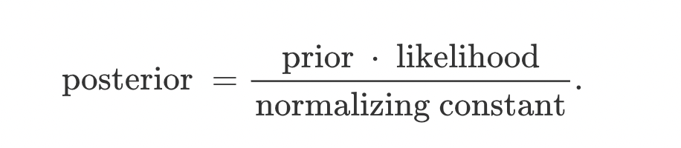

## 2.4 Chapter summary

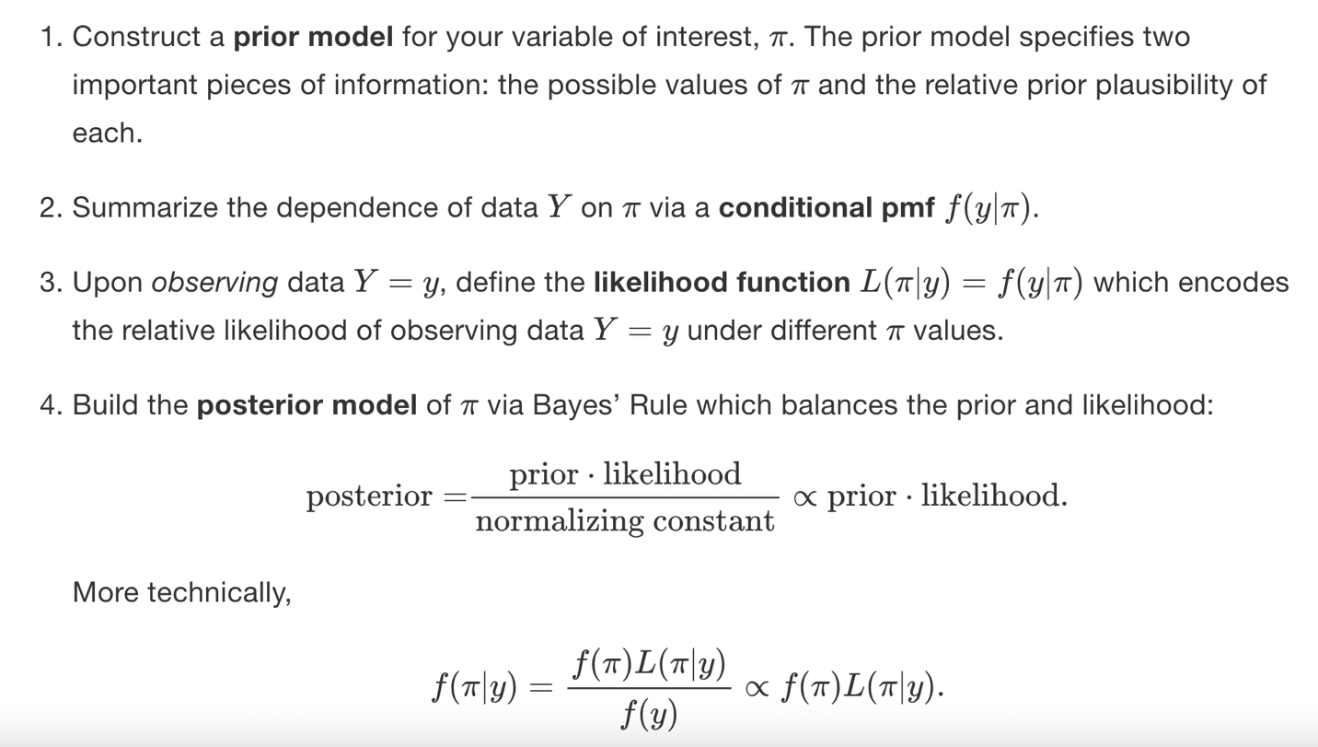

# Chapter 3 The Beta-Binomial Bayesian Model

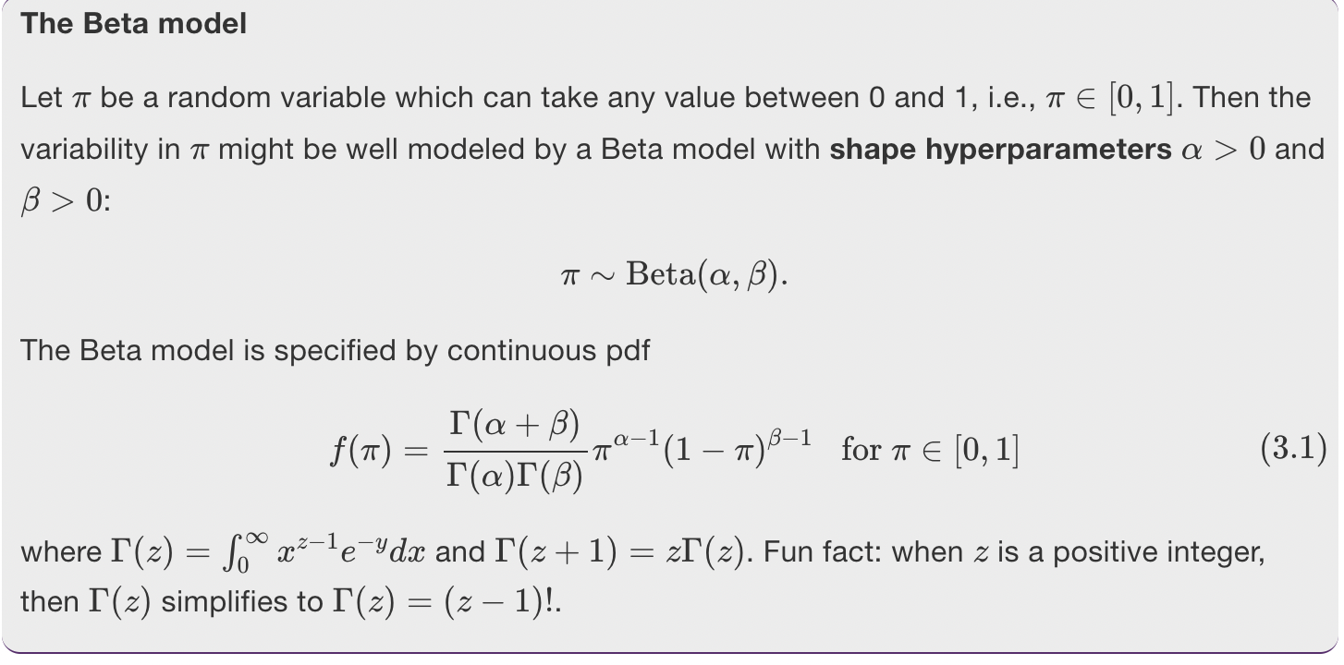

**Hyperparameter**

A hyperparameter is a parameter used in a prior model.

This flexibility means that we can *tune* the Beta to reflect our prior understanding of ππ by tweaking αα and ββ. For example, notice that when we set α=β=1α=β=1 (middle left plot), the Beta model is *flat* from 0 to 1. In this setting, the Beta model is equivalent to perhaps a more familiar model, the standard Uniform.

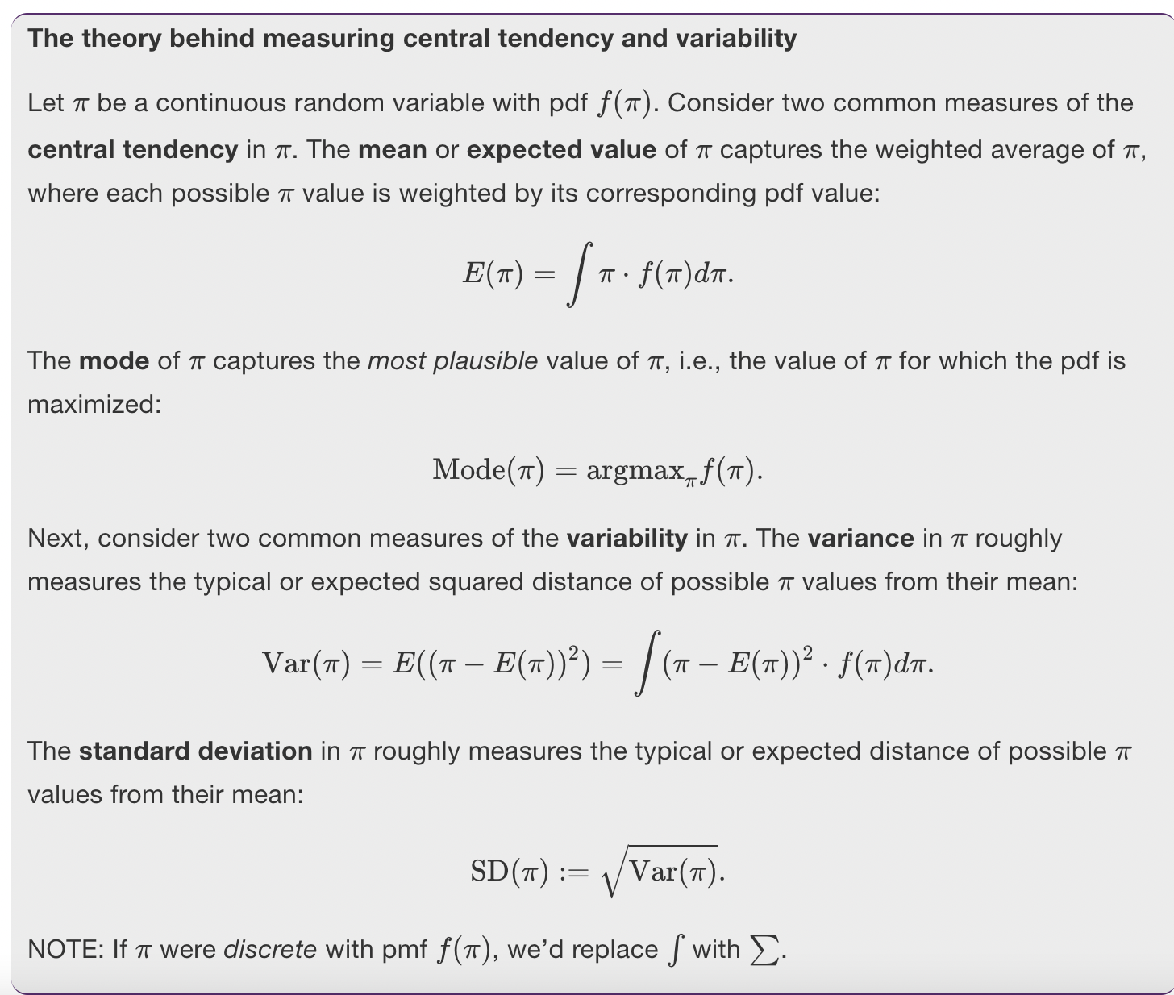

## 3.2 The Binomial data model & likelihood function

To begin, the conditional pmf f(y|π)f(y|π) provides answers to a hypothetical question: if Michelle’s support were some given value of ππ, then how many of the 50 polled voters Y=yY=y might we expect to support her? Figure [3.4](https://www.bayesrulesbook.com/chapter-3.html#fig:binoms-3) plots this pmf under a range of possible ππ.

## 3.4 The Beta-Binomial model

Importantly, notice that the posterior follows a different parameterization of the same probability model as the prior – both the prior and posterior are Beta models with different tunings. In this case, we say that the Beta(α,βα,β) model is a **conjugate prior** for the corresponding Bin(n,πn,π) data model.

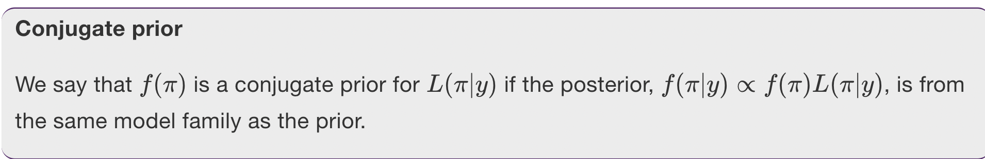

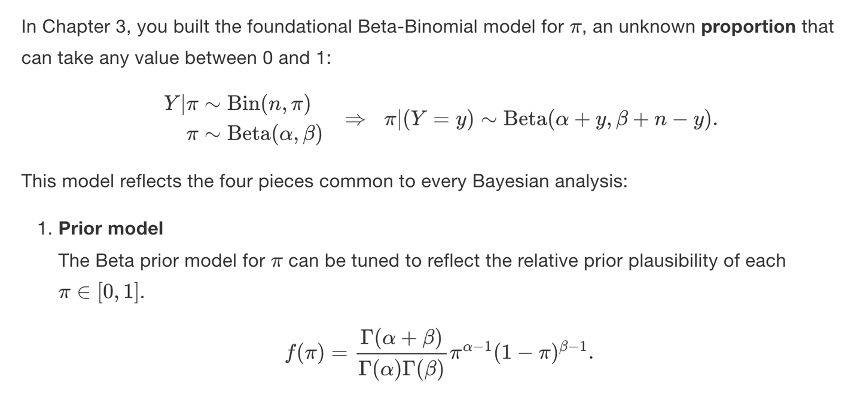

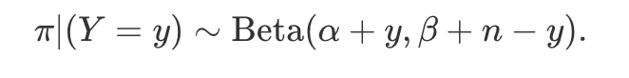

Importantly, notice that the posterior follows a different parameterization of the same probability model as the prior – both the prior and posterior are Beta models with different tunings. In this case, we say that the Beta(α,βα,β) model is a **conjugate prior** for the corresponding Bin(n,πn,π) data model.

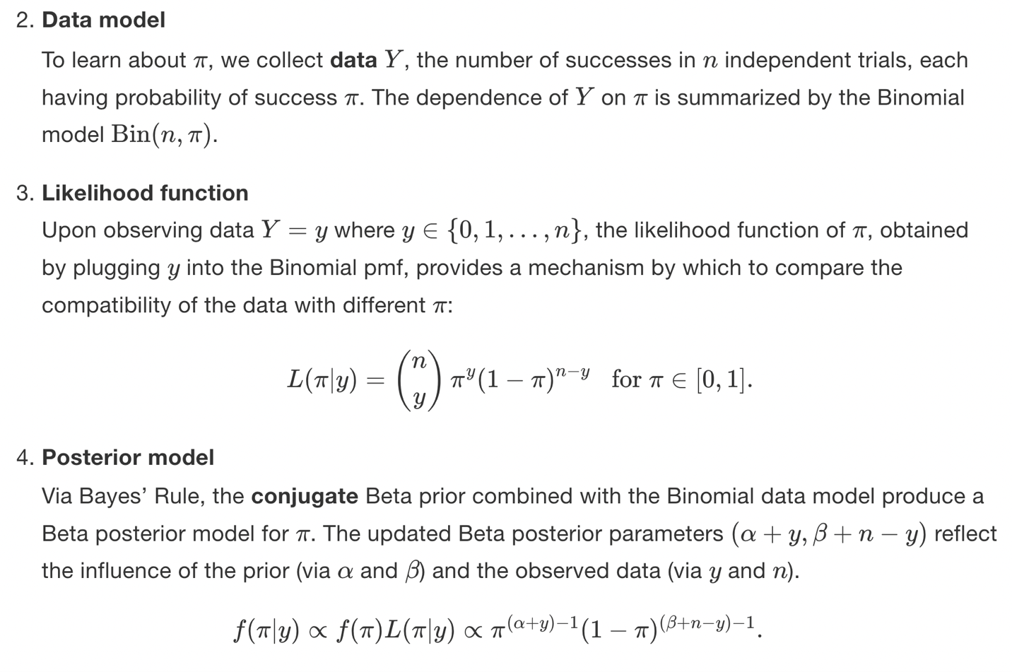

# Chapter 4 Balance and Sequentiality in Bayesian Analyses

## 4.1 Different priors, different posteriors

Not only do the differing **prior means** reflect disagreement about whether ππ is closer to 0 or 1, the differing levels of **prior variability** reflect the fact that the analysts have different degrees of certainty in their prior information. Loosely speaking, the more **certain** the prior information, the *smaller* the prior variability. The more **vague** the prior information, the *greater* the prior variability.

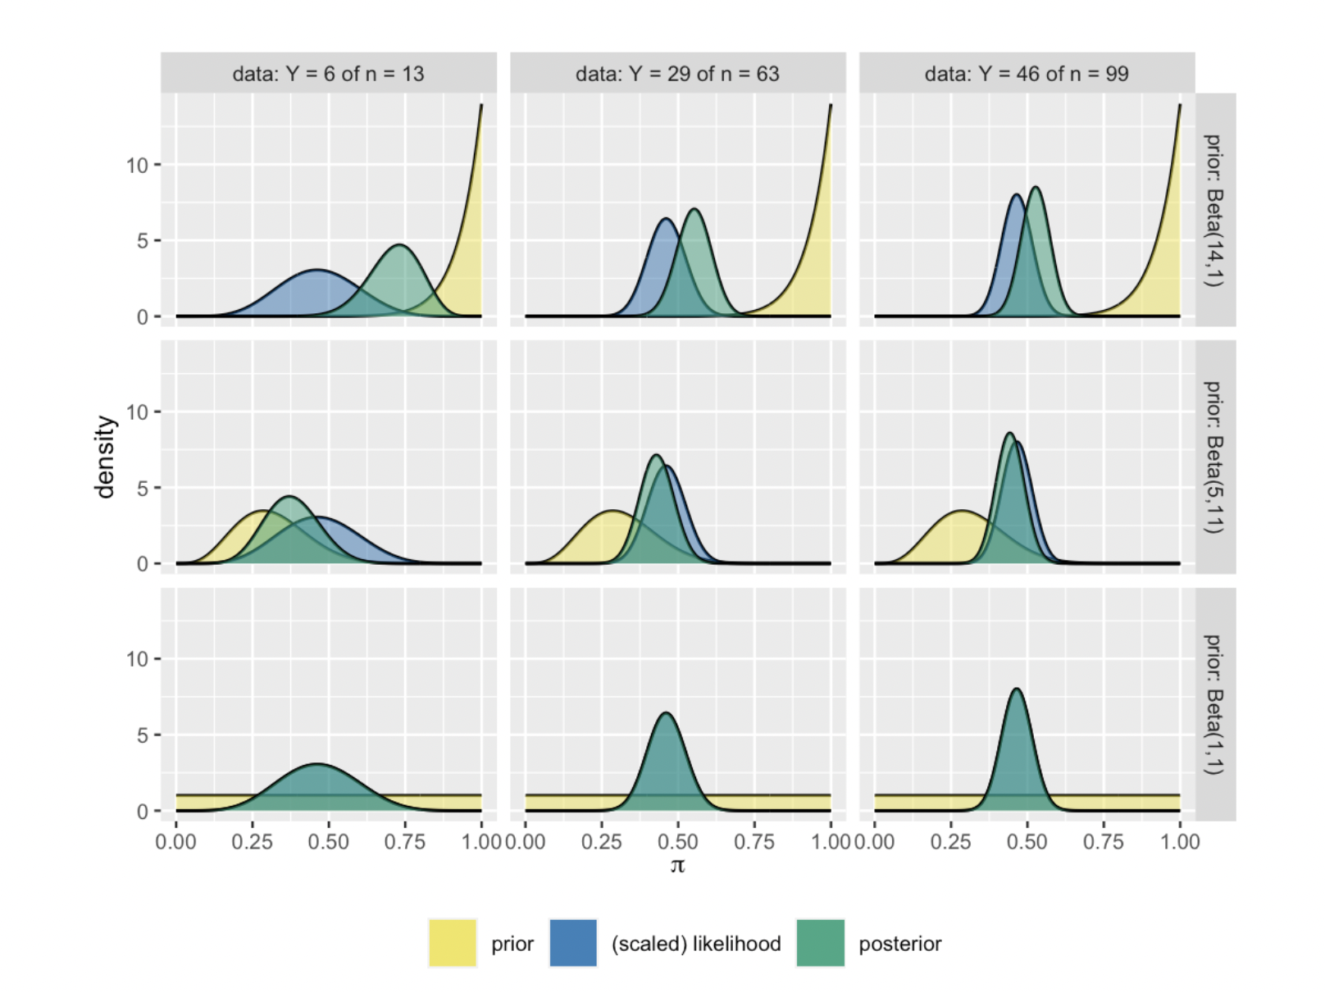

## 4.4 Sequential analysis: Evolving with data

First, the final posterior model is **data order invariant**, i.e., it isn’t impacted by the *order* in which we observe the data.

For example, suppose that the psychologist had observed Milgram’s study data in the reverse order: Y=8Y=8 of n=10n=10 on day one, Y=17Y=17 of n=20n=20 on day two, and Y=1Y=1 of n=10n=10 on day three. The resulting evolution in their understanding of ππ is summarized by Table [4.4](https://www.bayesrulesbook.com/chapter-4.html#tab:ch4-sequential-table-2) and Figure [4.6](https://www.bayesrulesbook.com/chapter-4.html#fig:ch4-sequential-plot-2).

The implications of this math are huge. No matter how much counterevidence the stubborn researcher collects, their posterior will *never* budge beyond the 0.25 cap, not even if they collect data on a billion subjects.

* **Prior influence**  
  The less **vague** and more **informative** the prior, i.e., the greater our prior certainty, the more influence the prior has over the posterior.
* **Data influence**  
  The more data we have, the more influence the data has over the posterior. Thus, if they have ample data, two researchers with different priors will have similar posteriors.

**Conjugate prior**

Let the prior model for parameter θθ have pdf f(θ)f(θ) and the model of data YY conditioned on θθ have likelihood function L(θ|y)L(θ|y). If the resulting posterior model with pdf f(θ|y)∝f(θ)L(θ|y)f(θ|y)∝f(θ)L(θ|y) is of the same model family as the prior, then we say this is a **conjugate prior**.

## 5.2 Gamma-Poisson conjugate family

 First, λλ is *not* a proportion limited to be between 0 and 1, but rather a rate parameter that can take on any *positive* value (e.g., we can’t receive -7 calls per day). Thus, a Beta prior for λλ won’t work. Further, each data point YiYi is a *count* that can technically take on any non-negative integer in {0,1,2,…}{0,1,2,…}, and thus is *not* limited by some number of trials nn as is true for the Binomial. Not to fret. Our study of λλ will introduce us to a *new* conjugate family, the **Gamma-Poisson**.

Yet in weighing the evidence of the phone call data, we won’t want to analyze each *individual* day. Rather, we’ll need to process the *collective* or *joint* information in our nn data points. This information is captured by the **joint probability mass function**.

Once we observe actual sample data, we can flip this joint pmf on its head to define the **likelihood function** of λλ. The Poisson likelihood function is equivalent in formula to the joint pmf f(→y|λ)f(y→|λ), yet is a function of λλ which helps us assess the compatibility of different possible λλ values with our observed *collection* of sample data →yy→:

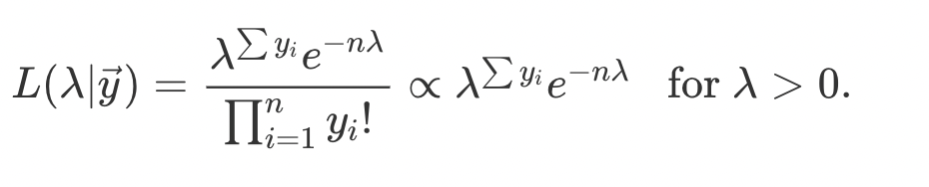

* Using conjugate priors allows us to have easy-to-derive and readily interpretable posterior models.
* The Beta-Binomial, Gamma-Poisson, and Normal-Normal conjugate families allow us to analyze data YY in different scenarios. The Beta-Binomial is convenient when our data YY is the number of successes in a set of nn trials, the Gamma-Poisson when YY is a count with no upper limit, and the Normal-Normal when YY is continuous.
* We can use several functions from the **bayesrules** package to explore these conjugate families: plot_poisson_likelihood(), plot_gamma(), plot_gamma_poisson(), summarize_gamma_poisson(), plot_normal(), plot_normal_normal(), and summarize_normal_normal().
* **Chapter 6 Approximating the Posterior**
* Fortunately, when a Bayesian posterior is either impossible or prohibitively difficult to specify, we’re not out of luck. We must simply change our strategy: instead of *specifying* the posterior, we can **approximate the posterior via simulation**.
* We’ll explore two simulation techniques: **grid approximation** and **Markov chain Monte Carlo (MCMC)**.

## 6.1 Grid approximation

Imagine there’s an image that you can’t view in its entirety – you only observe snippets along a grid that sweeps from left to right across the image. The finer the grid, the clearer the image. And if the grid is fine enough, the result is an excellent approximation of the complete image:



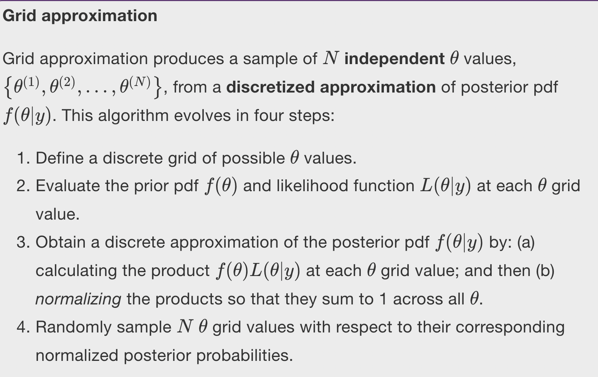

As **Step 1**, we need to split the continuum of possible ππ values on 0 to 1 into a finite grid. We’ll start with a course grid of only 6 ππ values, π∈{0,0.2,0.4,0.6,0.8,1}π∈{0,0.2,0.4,0.6,0.8,1}:

In **Step 2** we use dbeta() and dbinom(), respectively, to evaluate the Beta(2,2)Beta(2,2) prior pdf and Bin(10,π)Bin(10,π) likelihood function with Y=9Y=9 at each ππ in pi_grid:

In **Step 3**, we calculate the product of the likelihood and prior at each grid value. This provides an *unnormalized* discrete approximation of the posterior pdf that doesn’t sum to one. We subsequently **normalize** this approximation by dividing each unnormalized posterior value by their collective sum:

The resulting discretized posterior pdf, rounded to 2 decimal places and plotted below, provides a very rigid glimpse into the *actual* posterior pdf. It places a roughly 99% chance on ππ being either 0.6 or 0.8, a 1% chance on ππ being 0.4, and a near 0% chance on the other 3 ππ grid values:

You might anticipate what will happen when we use this approximation to simulate samples from the posterior in **Step 4**. Each sample draw has only 6 possible outcomes and is highly likely to be 0.6 or 0.8. Let’s try it: use sample_n() to take a sample of size = 10000 values from the 6-length grid_data, with replacement, and using the discretized posterior probabilities as sample weights.

Remember the rainbow image and how we got a more complete picture by viewing snippets along a finer grid? Similarly, instead of chopping up the 0-to-1 continuum of possible ππ values into a grid of only 6 values, let’s try a more reasonable grid of **101** values: π∈{0,0.01,0.02,…,0.99,1}π∈{0,0.01,0.02,…,0.99,1}. The first 3 grid approximation steps using this refined grid are performed below:

### 6.1.2 A Gamma-Poisson example

To *simulate* this posterior using grid approximation, **Step 1** is to specify a discrete grid of reasonable λ values. Unlike the ππ parameter in the Beta-Binomial which is restricted to the finite 0-to-1 interval, the Poisson parameter λ can technically take on any non-negative real value (λ∈[0,∞)λ∈[0,∞)). However, in a plot of the Gamma prior pdf and Poisson likelihood function it appears that, though possible, values of λ beyond 15 are implausible

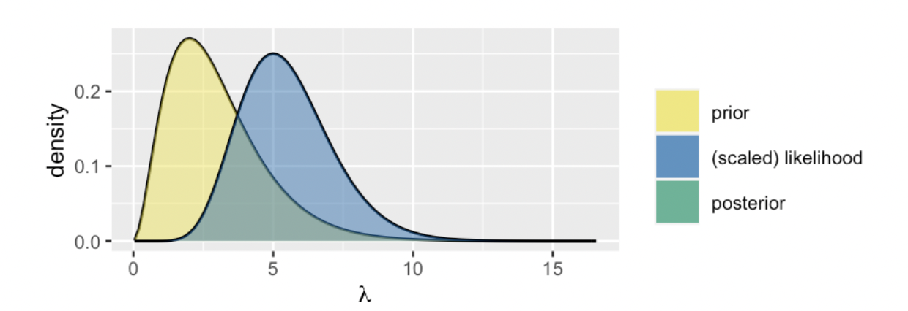

Limitations in the grid approximation method quickly present themselves as our models get more complicated. For example, by the end of Unit 4 we’ll be working with models that have *lots* of model parameters θ=(θ1,θ2,…,θk)θ=(θ1,θ2,…,θk). In such settings, grid approximation suffers from the **curse of dimensionality**.



When we chop *both* the x- and y-axes into grids, there are bigger *gaps* in the image approximation. To achieve a more refined approximation, we need a finer grid than when we only chopped the x-axis into a grid. Analogously, when using grid approximation to simulate multivariate posteriors, we need to divide the multidimensional sample space of θ=(θ1,θ2,…,θk)θ=(θ1,θ2,…,θk) into a very, very fine grid in order to prevent big gaps in our approximation. In practice, this might not be feasible. When evaluated on finer and finer grids, the grid approximation method becomes computationally expensive.

## 6.2 Markov chains via rstan

Today, “Markov chain Monte Carlo” refers to the application of Markov chains to simulate probability models using methods pioneered by the Monte Carlo project.

Like grid approximation samples, **MCMC samples are *not* taken directly from the posterior pdf**f(θ|y)f(θ|y). Yet unlike grid approximation samples, **MCMC samples aren’t even independent** – each subsequent sample value depends directly upon the previous value.

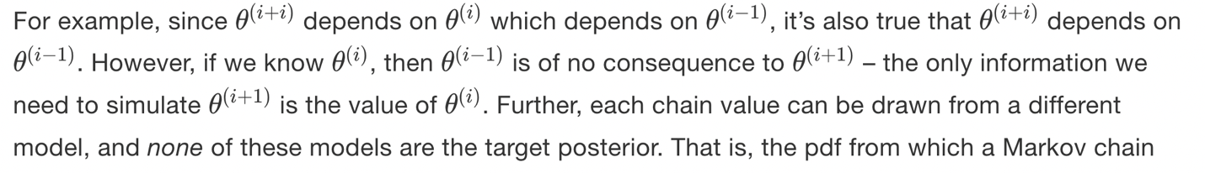

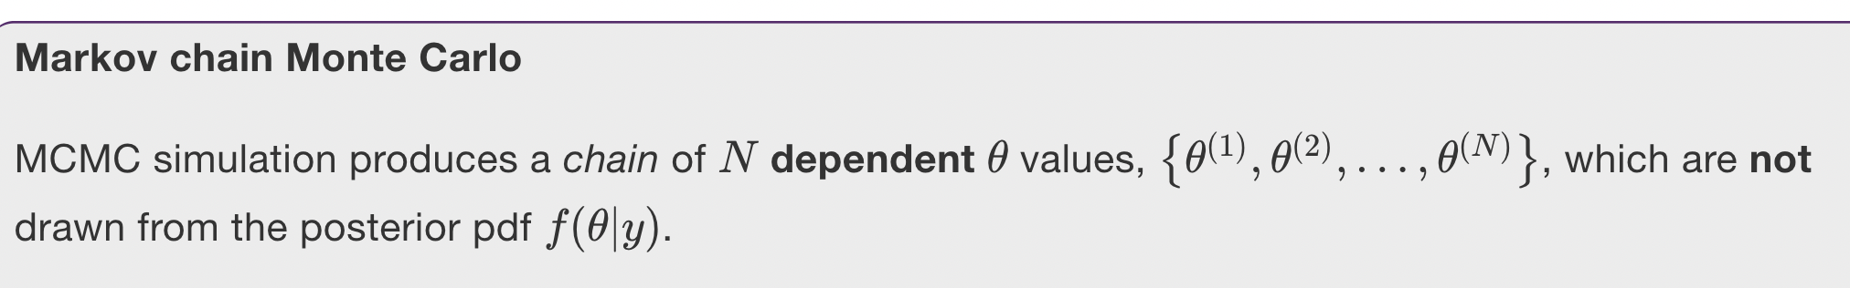

### 6.2.1 A Beta-Binomial example

 In defining the structure of this model, we must specify the three aspects upon which it depends:

* data  
  Data YY is the observed number of successes in 10 trials. Since **rstan** isn’t a mind reader, we must specify that YY is an integer between 0 and 10.
* parameters  
  The model depends upon parameter ππ, or pi in **rstan** notation. We must specify that ππ can be any real number between 0 and 1.
* model  
  The model is defined by the Bin(10,π)Bin(10,π) model for data YY and the Beta(2,2)(2,2) prior for ππ. We specify these using binomial() and beta().

Below we translate this Beta-Binomial structure into **rstan** syntax and store it as the character string bb_model. We encourage you to pause and examine the code, noting how it matches up with the three aspects above.

Since stan() has to do the double duty of identifying an appropriate MCMC algorithm for simulating the given model, and then applying this algorithm to our data, the simulation will be quite slow for each new model.

Note that stan() requires two types of arguments. First, we must specify the **model information** by:

* model_code = the character string defining the model (here bb_model)
* data = a list of the observed data (here Y = 9).

Second, we must specify the desired **Markov chain information** using three additional arguments:

* The chains argument specifies how many **parallel Markov chains** to run. We run four chains here, thus obtain four distinct samples of ππ values. We discuss this choice in Section [6.3](https://www.bayesrulesbook.com/chapter-6.html#diagnostics).
* The iter argument specifies the desired number of **iterations** in, or length of, each Markov chain. By default, the first half of these iterations are thrown out as “burn-in” or “warm-up” samples (see below for details). The second half are kept as the final Markov chain sample.
* To set the random number generating seed for an **rstan** simulation, we utilize the seed argument within the stan() function.

The result, stored in bb_sim, is a stanfit object. This object includes four parallel Markov chains run for 10,000 iterations each. After tossing out the first 5,000 iterations of all four chains, we end up with four separate Markov chain samples of size 5,000, or a combined **Markov chain sample size** of 20,000.

Without direct knowledge of the posterior it’s trying to simulate, the Markov chain might start out sampling unreasonable values of our parameter of interest, say ππ. Eventually though, it *learns* and starts producing values that mimic a random sample from the posterior. And just as we might need to toss out the first pancake, we might want to toss the Markov chain values produced during this learning period – keeping them in our sample might lead to a poor posterior approximation. As such, “burn-in” is the practice of discarding the first portion of Markov chain values.

Marking the sequence of the chain values, the trace plots in Figure [6.9](https://www.bayesrulesbook.com/chapter-6.html#fig:ch-6-trace-1) illuminate the Markov chains’ **longitudinal** behavior. We also want to examine the **distribution** of the values these chains visit along their journey, ignoring the order of these visits. The histogram and density plot in Figure [6.10](https://www.bayesrulesbook.com/chapter-6.html#fig:ch-6-sim) provide a snapshot of this distribution for the combined 20,000 chain values, 5,000 from each of the four separate chains. Notice the important punchline here: the distribution of the Markov chain values is an excellent approximation of the target Beta(11, 3) posterior model of ππ (superimposed in black). That’s a relief – that was the whole point.

## 6.3 Markov chain diagnostics

In this section, we’ll focus on a couple visual diagnostic tools that will get us started: **trace plots** and **parallel chains**. These can be followed up with and supplemented by a few numerical diagnostics: **effective sample size**, **autocorrelation**, and **R-hat (**^RR^**)**. Utilizing these diagnostics should be done *holistically*. Since no single visual or numerical diagnostic is one-size-fits-all, they provide a fuller picture of Markov chain quality when considered together. Further, other excellent diagnostics exist. We focus here on those that are common and easy to implement in the software packages we’ll be using.

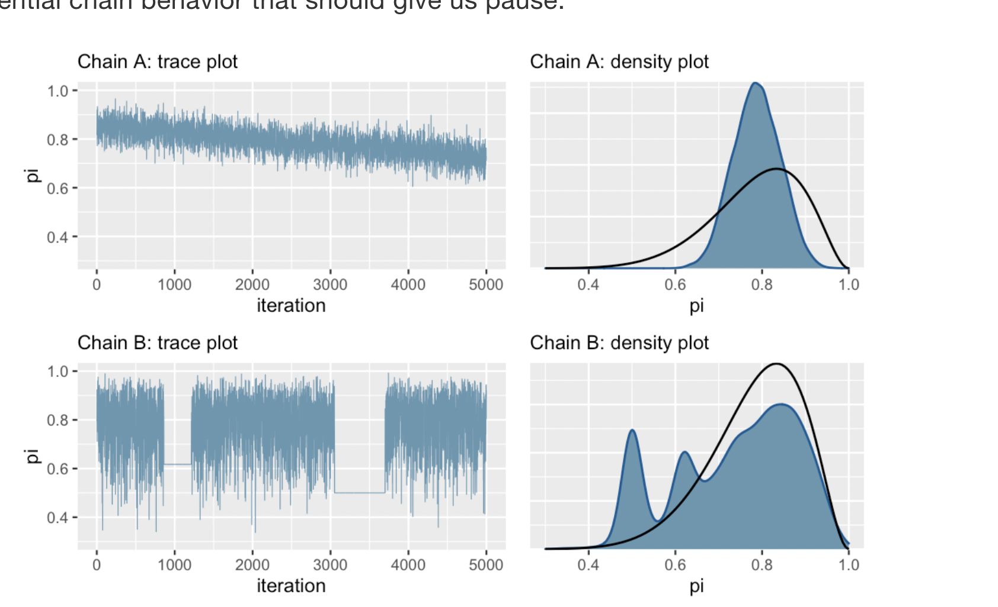

First, consider the trace plots in Figure [6.12](https://www.bayesrulesbook.com/chapter-6.html#fig:bad-trace) (left). The downward trend in Chain A indicates that it has not yet stabilized after 5,000 iterations – it has not yet “found” or does not yet know how to explore the range of posterior plausible ππ values. The downward trend also hints at strong correlation among the chain values – they don’t look like independent noise. All of this to say that Chain A is **mixing slowly**. This is bad. Though Markov chains are inherently dependent, the more they *behave* like fast mixing (noisy) independent samples, the smaller the error in the resulting posterior approximation (roughly speaking).

Chain B exhibits a different problem. As evidenced by the two completely flat lines in the trace plot, it tends to get *stuck* when it visits smaller values of ππ.

The density plots in Figure [6.12](https://www.bayesrulesbook.com/chapter-6.html#fig:bad-trace) (right) confirm that both of these goofy-looking chains result in a serious issue: they produce poor approximations of the Beta(11,3) posterior (superimposed in black), and thus misleading posterior conclusions.

This is why diagnostics are so important. If we see bad trace plots like those in Figure [6.12](https://www.bayesrulesbook.com/chapter-6.html#fig:bad-trace), there are some immediate steps we can take:

1. Check the model. Are the assumed prior and data models appropriate?
2. Run the chain for more iterations. Some undesirable short-term chain trends might iron out in the long term.

### 6.3.2 Comparing parallel chains

Recall that our stan() simulation for the Beta-Binomial model produced four parallel Markov chains. Not only do we want to see stability in each individual chain (as discussed above), we want to see consistency *across* the four chains.

### 6.3.3 Calculating effective sample size & autocorrelation

To begin, recall that our Markov chain simulation bb_sim produced a combined 20,000 *dependent* values of ππ, sampled from models *other* than the posterior. We then used this chain to approximate the posterior model of π.

Relatively, how many independent sample values would it take to produce an equivalently accurate posterior approximation? The **effective sample size ratio** provides an answer.

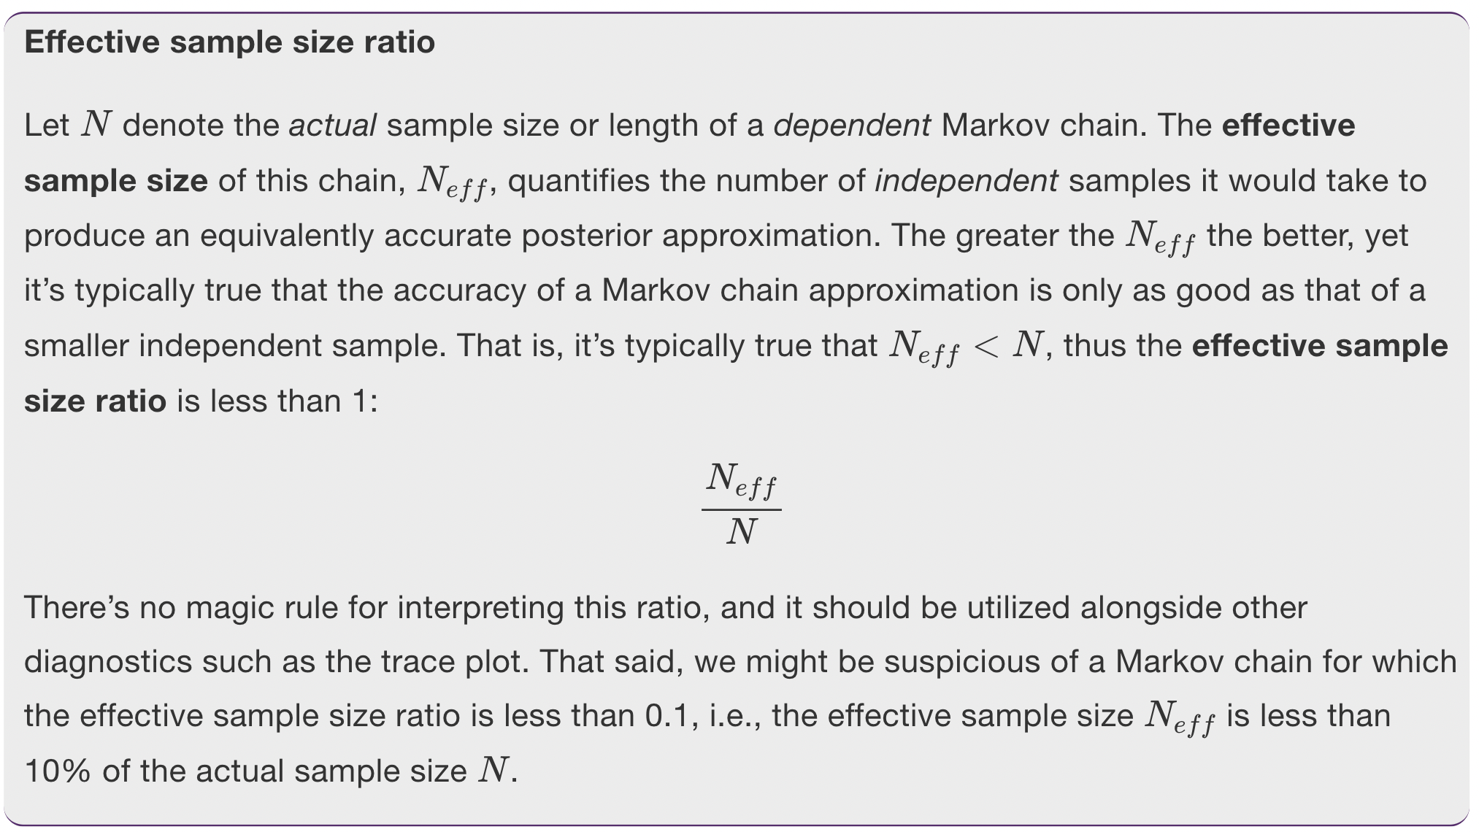

**Autocorrelation** provides another metric by which to evaluate whether our Markov chain sufficiently mimics the behavior of an independent sample. *Strong* autocorrelation or dependence is a bad thing – it goes hand in hand with small effective sample size ratios, and thus provides a warning sign that our resulting posterior approximations might be unreliable.

This chain of dependencies also means that each chain value depends in some degree on all previous chain values. For example, since π(i)π(i) is dependent on π(i−1)π(i−1) which is dependent on π(i−2)π(i−2), π(i)π(i) is *also* dependent on π(i−2)π(i−2). Yet this dependence, or autocorrelation, fades.

**Autocorrelation**

**Lag 1** autocorrelation measures the correlation between pairs of Markov chain values that are one “step” apart (e.g., π(i)π(i) and π(i−1)π(i−1)). **Lag 2** autocorrelation measures the correlation between pairs of Markov chain values that are two “steps” apart (e.g., π(i)π(i) and π(i−2)π(i−2)). And so on.

From there, the lag 1 autocorrelation is roughly 0.5, indicating moderate correlation among chain values that are only 1 step apart. But then the autocorrelation quickly drops off and is effectively 0 by lag 5. That is, there’s very little correlation between Markov chain values that are more than a few steps apart. This is all good news. It’s more confirmation that our Markov chain is **mixing quickly**, i.e., quickly moving around the range of posterior plausible ππ values, and thus at least mimicking an independent sample.

Presuming you’ve never seen an autocorrelation plot before, we imagine that it’s not very obvious that the plot in Figure [6.15](https://www.bayesrulesbook.com/chapter-6.html#fig:ch6-acf-1) is a “good” one. For contrast, consider the results for an unhealthy Markov chain (Figure [6.16](https://www.bayesrulesbook.com/chapter-6.html#fig:ch6-acf-2)). The trace plot exhibits strong trends, and hence autocorrelation, in the Markov chain values. This observation is echoed and further formalized by the autocorrelation plot. The slow decrease in the autocorrelation curve indicates that the dependence between chain values does not quickly fade away.  In fact, there’s a roughly 0.9 correlation between Markov chain values that are a full 20 steps apart! Since its chain values are so strongly tied to the previous values, this chain is **slow mixing** – it would take a long time for it to adequately explore the full range of the posterior. Thus, just as with the slow mixing Chain A in Figure [6.12](https://www.bayesrulesbook.com/chapter-6.html#fig:bad-trace), we should be wary about using this chain to approximate the posterior. Let’s tie these ideas together.

**Slow mixing** chains do *not* enjoy the features of an independent sample: the chains move “slowly” around the range of posterior plausible values, the autocorrelation among the chain values drops off very slowly, and the effective sample size ratio is small.

So what do we do if ours is a dreaded slow mixing chain? The first and, in our opinion best, possible solution is the tried and true “run a longer chain.” Even a slow mixing chain can *eventually* produce a good posterior approximation if we run it for enough iterations.

There is a careful line to walk when deciding whether or not to thin a Markov chain. The benefits of reduced autocorrelation don’t necessarily outweigh the loss of precious chain values. That is, 5000 Markov chain values with stronger autocorrelation might produce a better posterior approximation than 500 chain values with weaker autocorrelation. The effectiveness of thinning also depends in part on the algorithm used to construct the Markov chain. For example, the **rstan** and **rstanarm** packages used throughout this book employ an efficient Hamiltonian Monte Carlo algorithm. As such, in the current stan() help file, the package authors advise *against* thinning unless your simulation hogs up too much memory on your machine.

### 6.3.4 Calculating R-hat

Just as effective sample size and autocorrelation provide numerical supplements to the visual trace plot diagnostic in assessing the degree to which a Markov chain behaves like an independent sample, the split-^RR^ metric (or “R-hat” for short) provides a numerical supplement to the visual comparison of parallel chains.

* in a “good” Markov chain simulation, the variability across all parallel chains combined will be roughly comparable to the variability within any individual chain;
* in a “bad” Markov chain simulation, the variability across all parallel chains combined might exceed the typical variability within each chain.

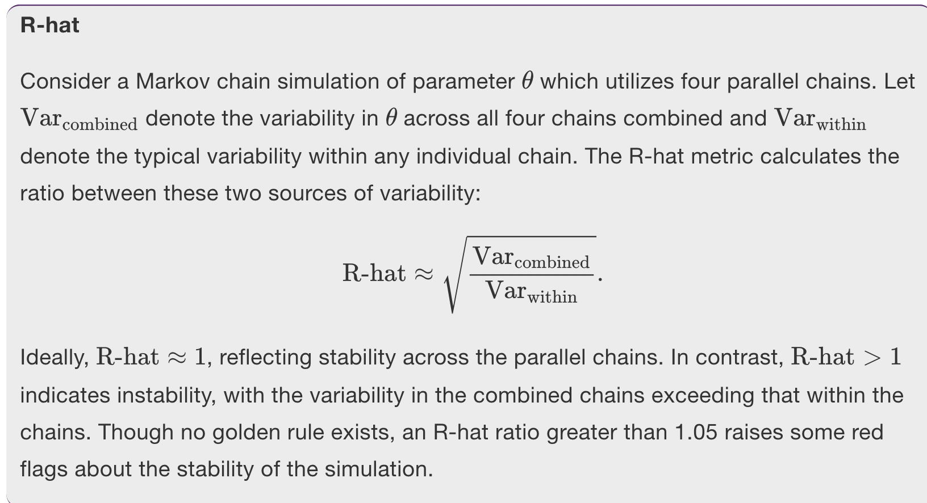

As our Bayesian models get more sophisticated, their posteriors will become too difficult, if not impossible, to specify. In Chapter 6, you learned two **simulation techniques** for **approximating the posterior** in such scenarios: grid approximation and Markov chain Monte Carlo. Both techniques produce a **sample** of NN θθ values,

{θ(1),θ(2),…,θ(N)}.{θ(1),θ(2),…,θ(N)}.

However, the properties of these samples differ:

